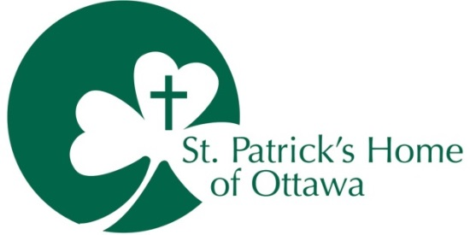

April 10, 2020
UPDATE TO ALL FAMILY AND FRIENDS
Hello,

On this Good Friday, as the Easter weekend starts, I know that you will be missing family celebrations as we are all practicing social distancing.

The purpose of social distancing is to stop the transmission of the virus from person to person by maintaining a 2 meter barrier between each other. If that 2 meter barrier cannot be maintained then the use of surgical or procedure mask of a medical grade is recommended for our residents. This is now our approach inside the home, with ongoing training to everyone on how to properly put on and take off the masks.

We will soon start to see warmer weather (we hope), and you may think that meeting your family outside for a visit would be another way to connect. Please do not meet your loved one outside the building. Public Health has asked that anyone (except direct caregivers) must keep a 2 meter distance from the residents to avoid a possible transmission. We are doing our best to limit face to face contacts to staff only. The public health experts are limiting visits in parks for the public in general and we are taking the same approach at St. Pat’s.

It would be very difficult for you and other families to maintain the requirements of social distancing and this could result in you spreading the virus unknowingly. It would also be very difficult for many of our residents to understand why you are not getting close, giving them hugs and kisses. I know that you do not want to add any undue confusion or stress to your loved one and will continue with the visit options in place such as Skype, window visits and telephone conversations.

In keeping with social distancing, you may have seen the drive by birthday party held at St. Pat’s yesterday in the news. What a wonderful creative way to celebrate in our strange new world. The Easter Bunny even dropped in early for the event.

We have no positive test results to date.

Please stay well,

Janet Morris
President & CEO

